Anna’s keywords in mind map form
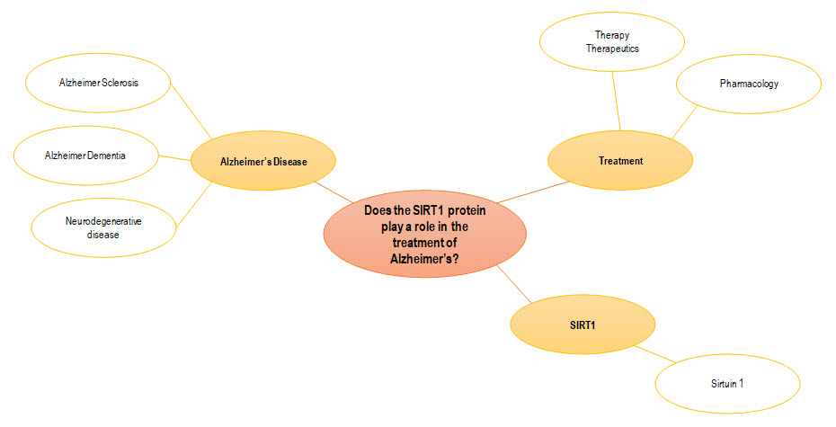

Anna’s keywords in table form

Research question:
Does the SIRT1 protein play a role in the treatment of Alzheimer’s Disease?
Alzheimer’s Disease | Treatment | SIRT1
Synonyms and Related Terms:  Alzheimer Syndrome*  Alzheimer Sclerosis*  Alzheimer Dementia*  General terms:  Neurodegenerative Disease  Tauopathy  Cortical atrophy | Therapy  Therapeutics  Pharmacology | Sirtuin 1

